**TASK** - 5 : **To Implement Cloud Analyst using Cloud Simulator.**

**AIM** : To Simulate the Cloud environment of three data centers in different geographical locations and add virtual machines to them along with resources like storage, compute and bandwidth using CloudAnalyst.

**DESCRIPTION :**

**Cloud Analyst**

Cloud Analyst is a tool developed at the University of Melbourne whose goal is to support evaluation of social networks tools according to geographic distribution of users and data centers. In this tool, communities of users and data centers supporting the social networks are characterized and, based on their location; parameters such as user experience while using the social network application and load on the data center are obtained/logged.

**Cloud Analyst** is built on top of the CloudSim tool kit, by extending CloudSim functionality with the introduction of concepts that model Internet and Internet Application behaviours.

**CloudSim** is a framework for modeling and simulation of cloud computing infrastructures and services. Originally built primarily at the Cloud Computing and Distributed Systems (CLOUDS) Laboratory,The University of Melbourne, Australia, CloudSim has become one of the most popular open source cloud simulators in the research and academia.

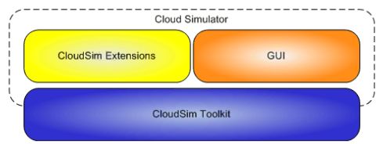

**Fig** : Cloud Analyst Design

**Region** : In the Cloud analyst the world is divided into 6 Regions that coincide with the 6 main components in the World. The other main entities such as User Bases and Data Centers belong to one of this regions.

**Cloud Application Service Broker** : The traffic routing between User Bases and Data Centers is controlled by a Service Broker that decides which Data Center should service the requests from each user base. Cloud Analyst implements three types of service brokers based on their

respective routing policy. They are Service Proximity based routing , Performance Optimized routing, Dynamically reconfiguring router..

**User Bases** : A User Base models a group of users that is considered as a single unit in the simulation and its main responsibility is to generate traffic for the simulation.

**Data Center Controller** : The Data Center Controller is probabaly the most important entity in the Cloud Analyst . A single Data Center Controller is mapped to a single cloudsim. DataCenter object and manages the data center management activities such as VM creation and destruction and does routing of users requests from User Bases via the Internet to the VMs.

**PROCEDURE :**

**Before heading towards the experiment first we have to run the simulator**

**1. First Download the Cloud Analyst from the below provided link.**

[**http://www.cloudbus.org/cloudsim/CloudAnalyst.zip**](http://www.cloudbus.org/cloudsim/CloudAnalyst.zip)

**2. Extract the Zip file and follow the below process to open the simulator**

**Download Zip file** **->** **Extract zipfile** **->** go to the **cloudanalyst folder** **->** open **jars** folder**-> right click and open in terminal** **->** we type the following command to open the simulator

In linux (ubuntu) Command : **java –jar cloudanalyst.jar**

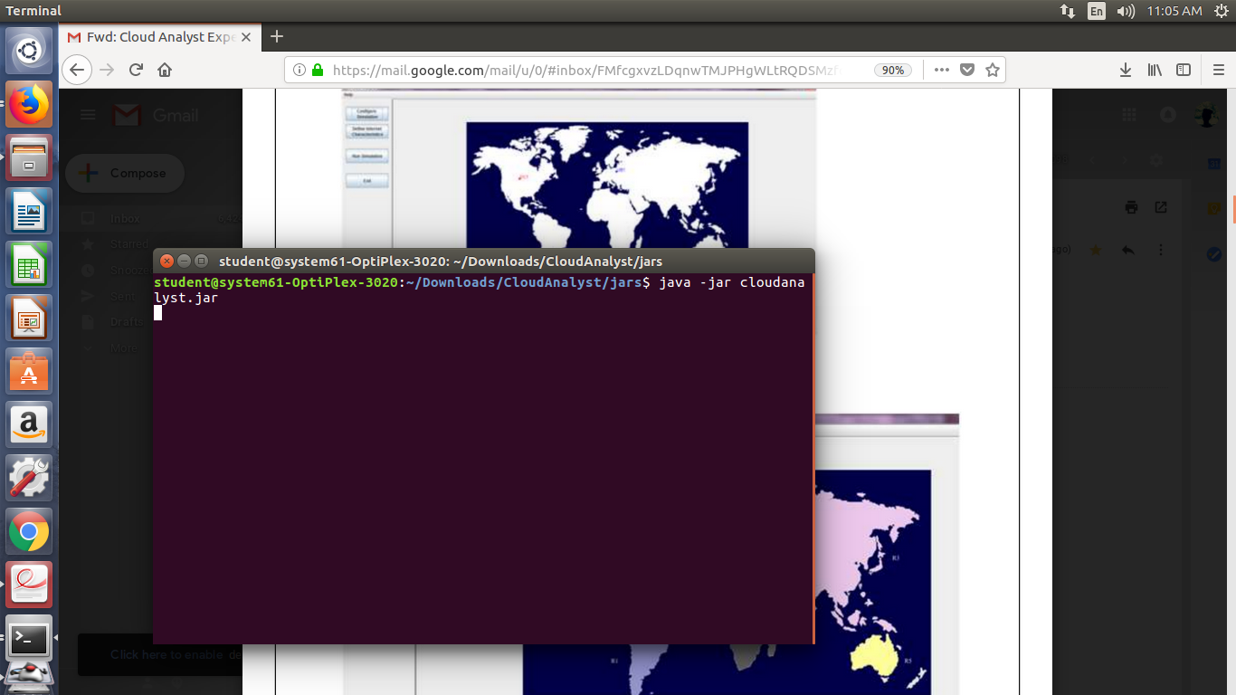

In case of **windows** OS do the following process in order to open the simulator.

Open **Cloudanalyst folde**r **- >** **cloudanalyst** **- >** you can see the following files and folders .

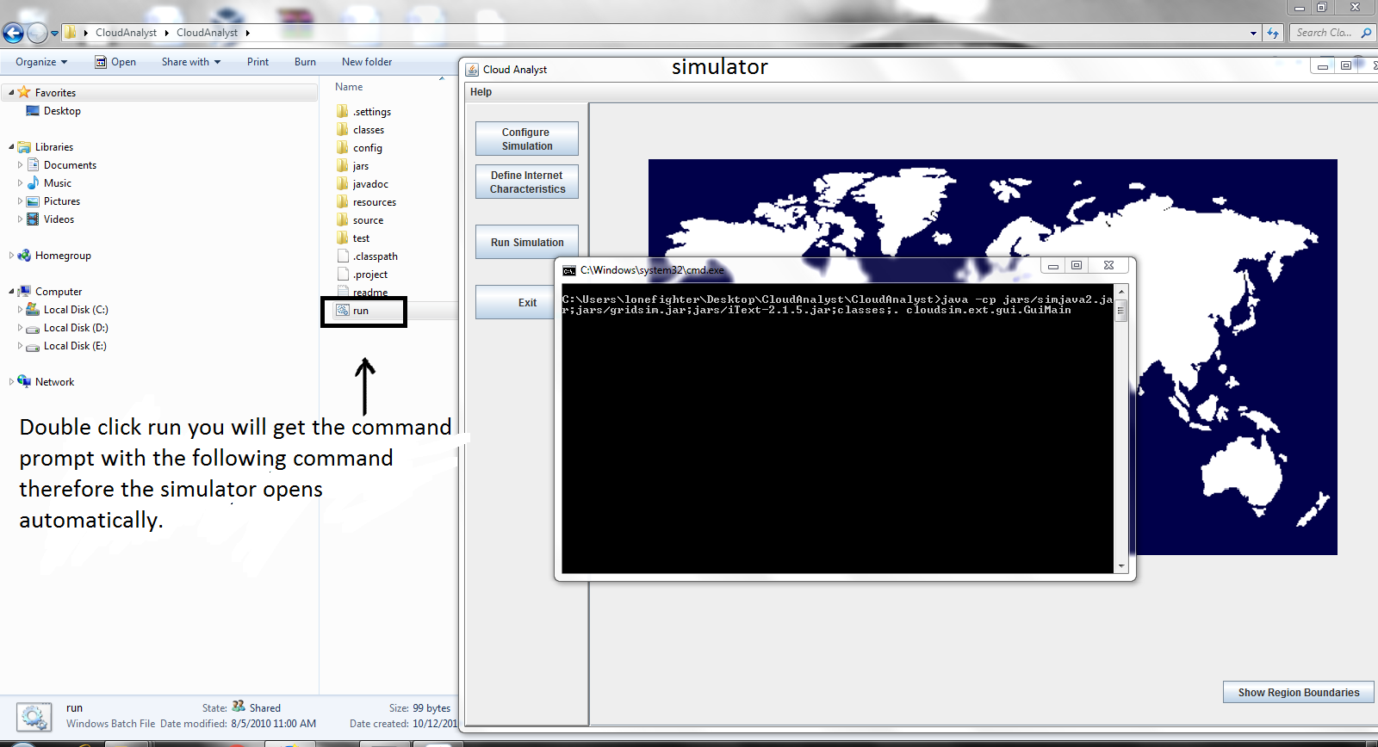

**3. Following Cloud Analyst Interface is seen when you click the run and proceed.**

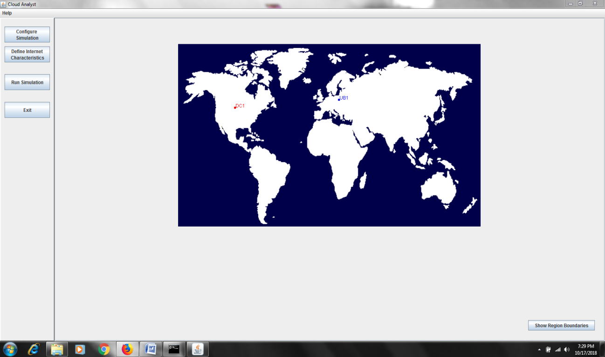

Click on the **Show Region Boundaries** to identify the range or limit of a particular region

The following figure shows the regions with separate colors..

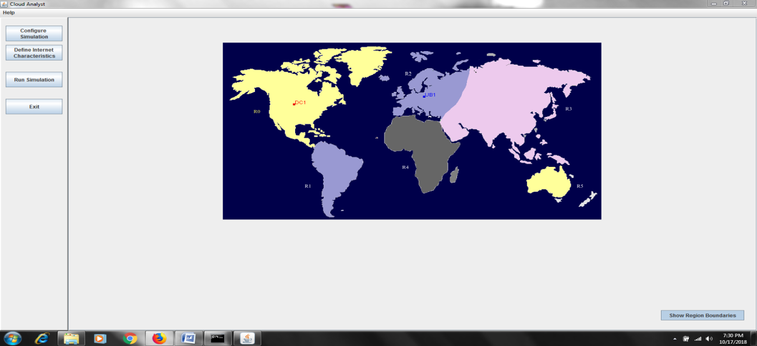

**4.**Click on the **Configure Simulation** to configure the Data Center Configuration and Main Configuration.

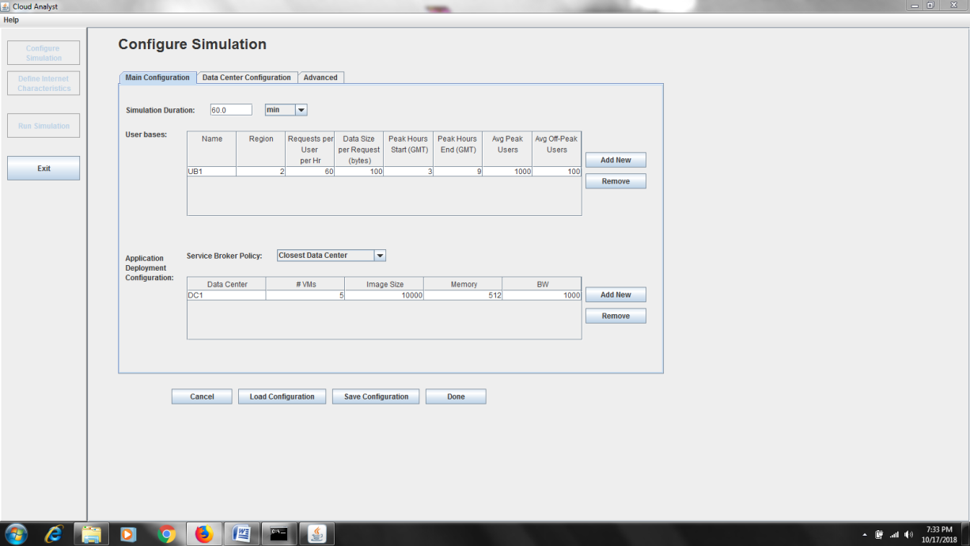

**5.** Click On the Data Center Configuration to configure the Datacenters.

Now click on Add New to add the data center, Here it is DC1 data center is created in region 0 with other configurations.

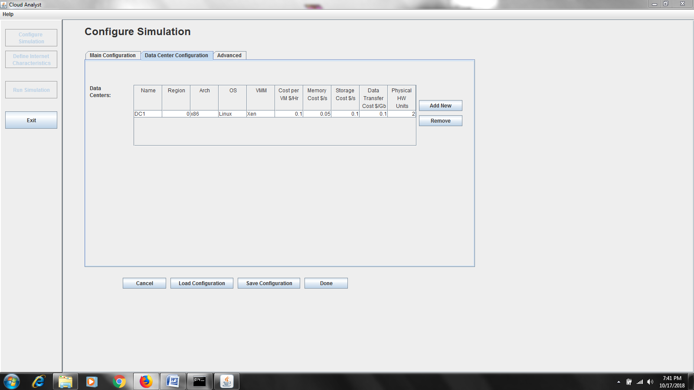

We will get the Physical Hardware details by clicking on the Name of the Data center (DC1) so that we can Add new host, copy or Remove them . Inorder to add new host just click on the Add New.

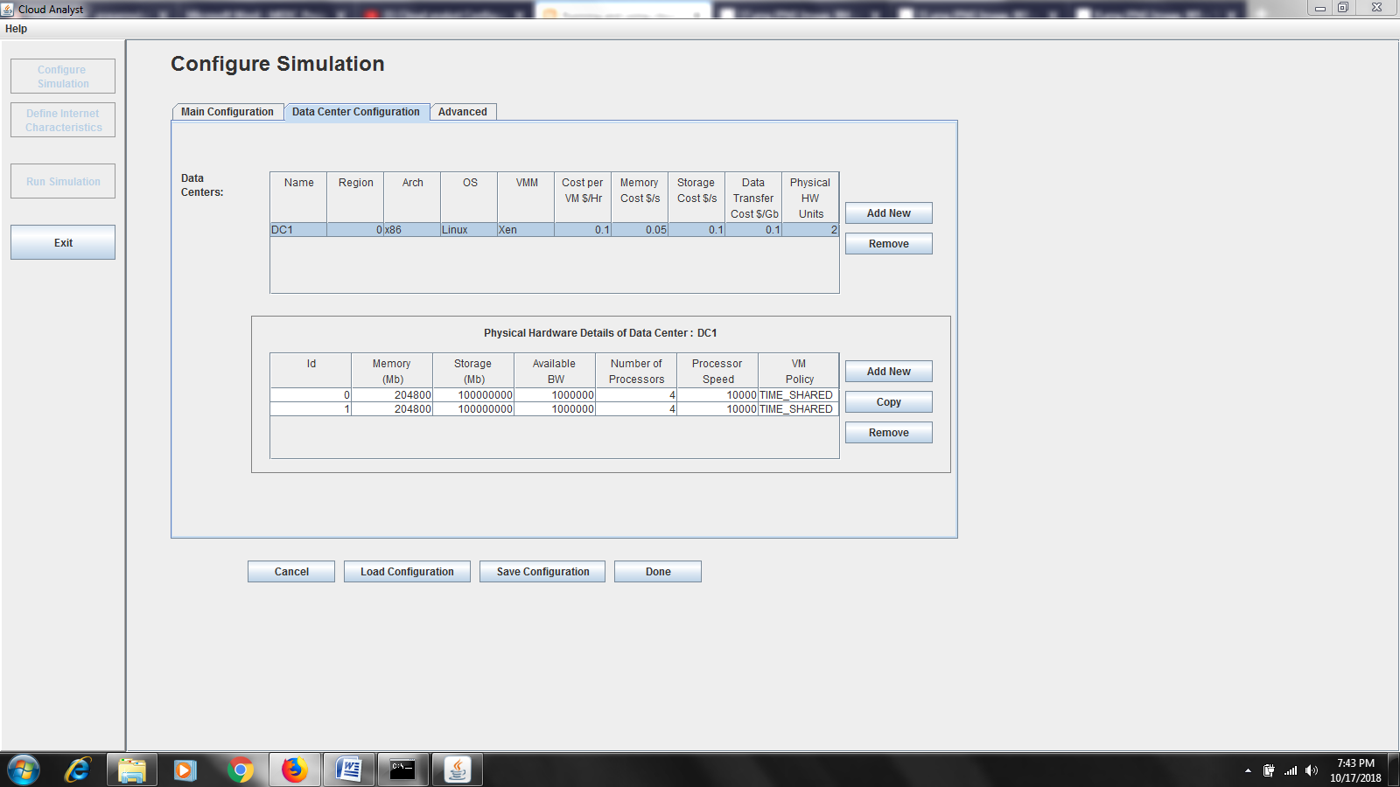

If you want to copy the host details just click on the copy and enter the number of copies that you want to copy in the pop up window and press ok.

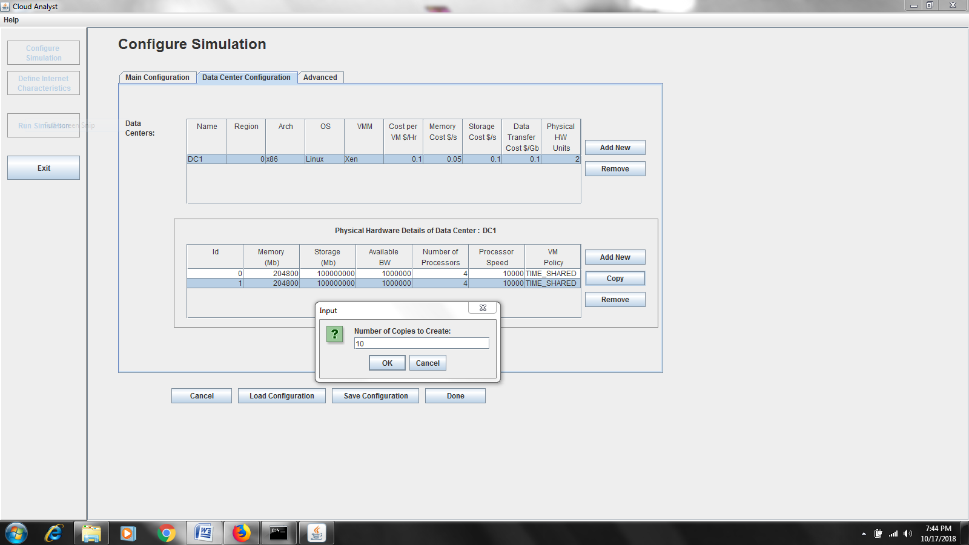

The following shows the list of all the 11 rows since 1 is already created we copied it so we got 11 rows .

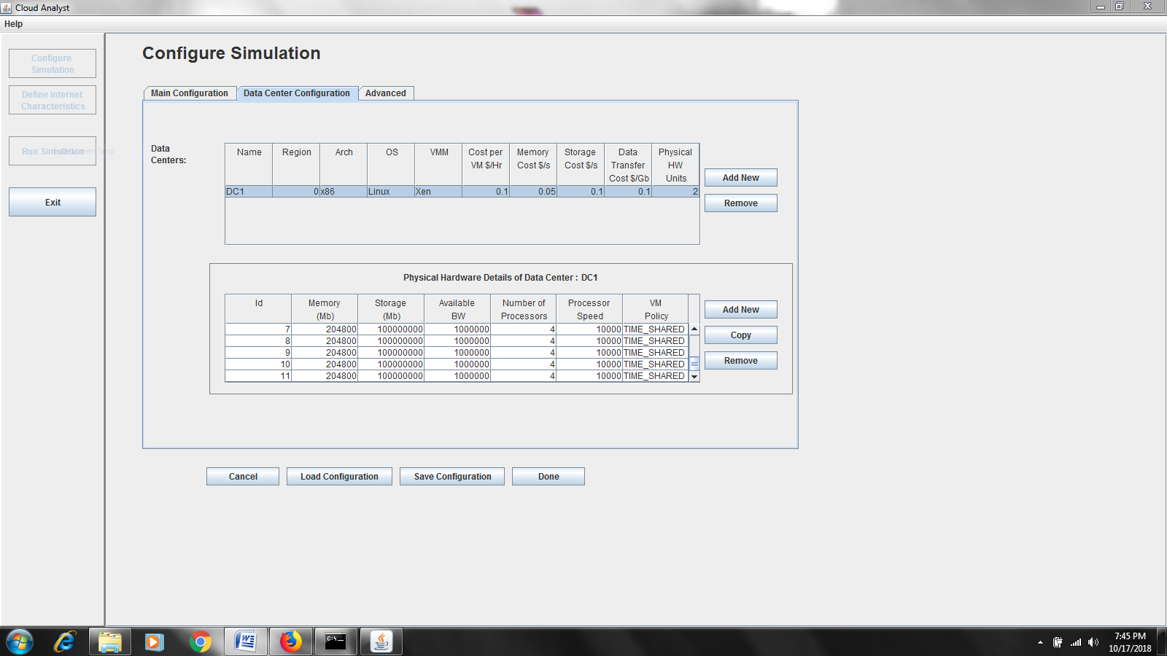

6.According to our experiment we want to simulate the cloud environment of three datacenters so we created three Data Centers namely DC1, DC2, DC3 with the regions as 0,2,5 (we can add any regions rangin from 0-5) i.e the locations where the Datacenters are located.

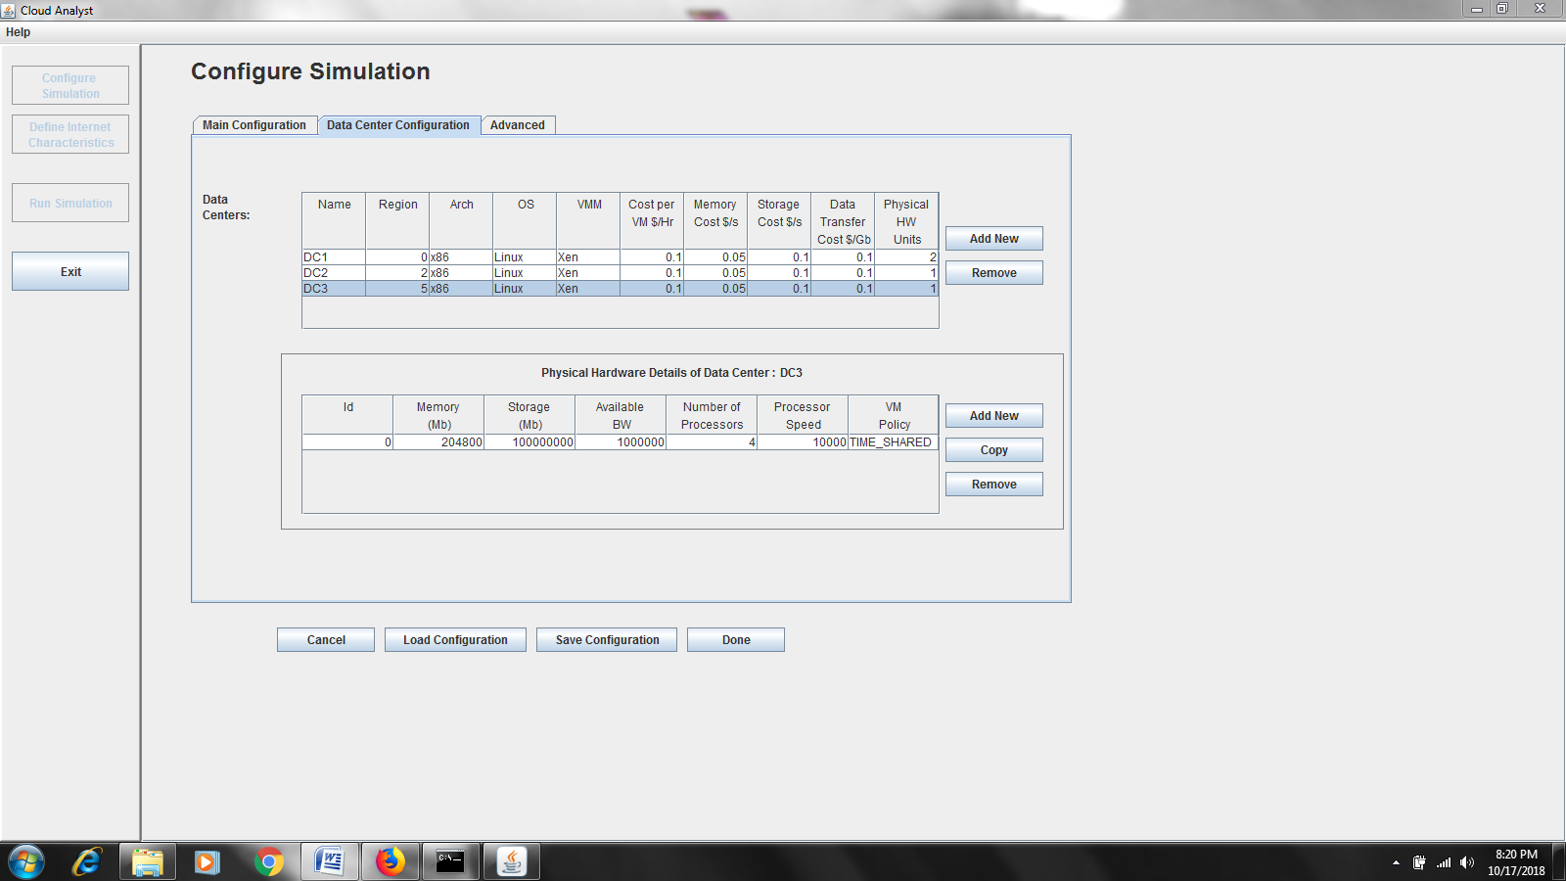

If we want to add or copy the Physical Hardware details of a particular data center just follow the above steps by adding new host or by copying the same host .

7.Click Main Configuration and Add three New UserBases namely UB1, UB2, UB3 in the regions 2, 3, 1 to which the datacenters are connected.

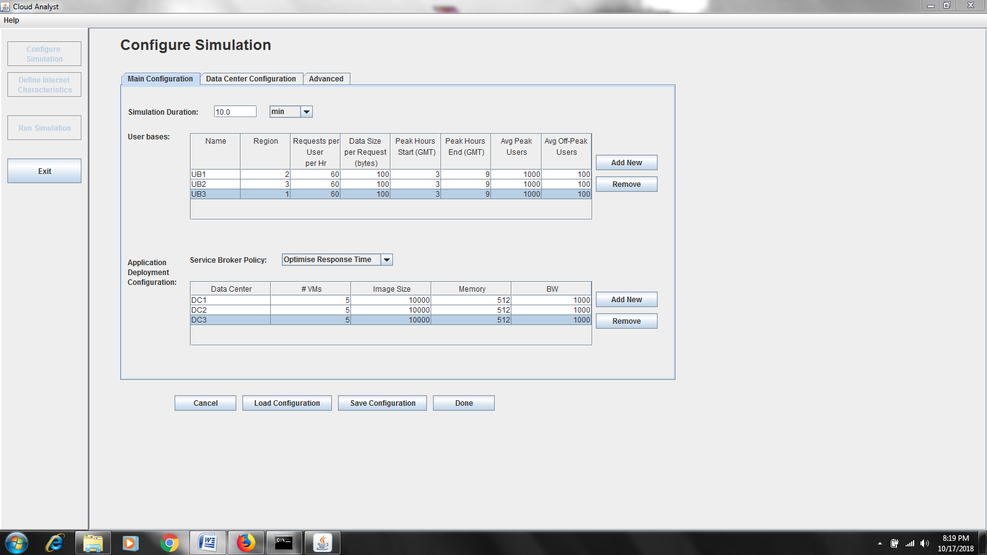

8.Now Click on the Save Configuration at the bottom and save it with any name and click Done.

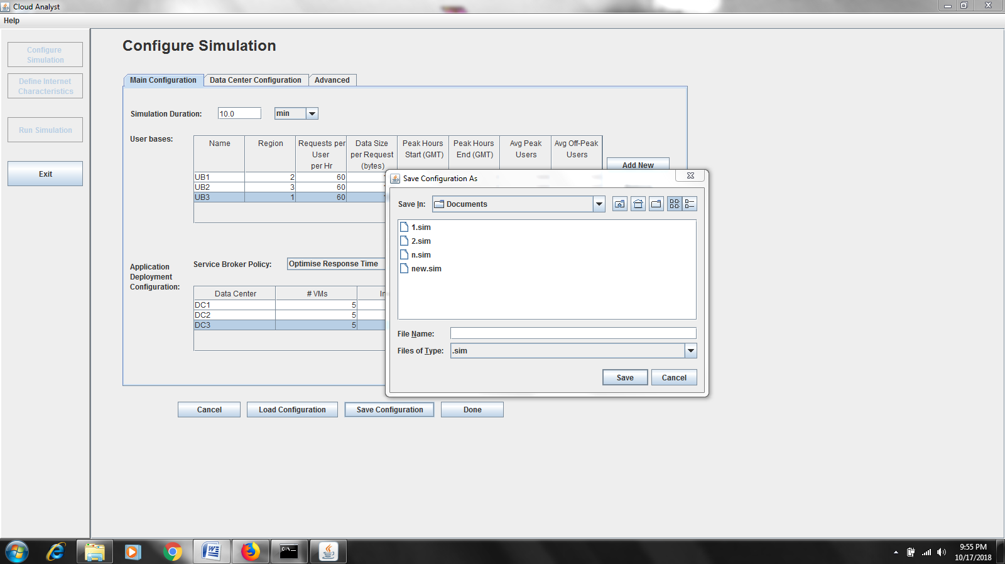

After that you will be prompted to the normal world map which you have seen prior to the experiment.

9. click Run Simulation where the simulation gets happened and you can see the data transmission between the datacenters and the userbases based on the input given by us.It gives a

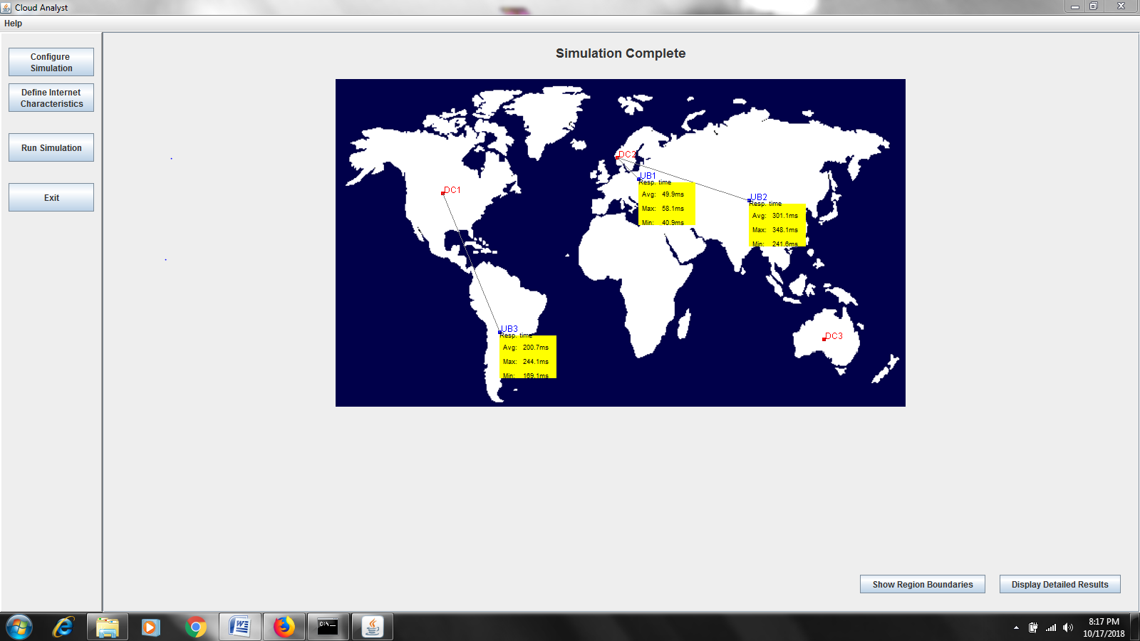

The Simulation Statistics are seen on the screen after running the simulation which is as follows .

It gives the information about the time, Datacenters and about the estimated cost of the VM’s .

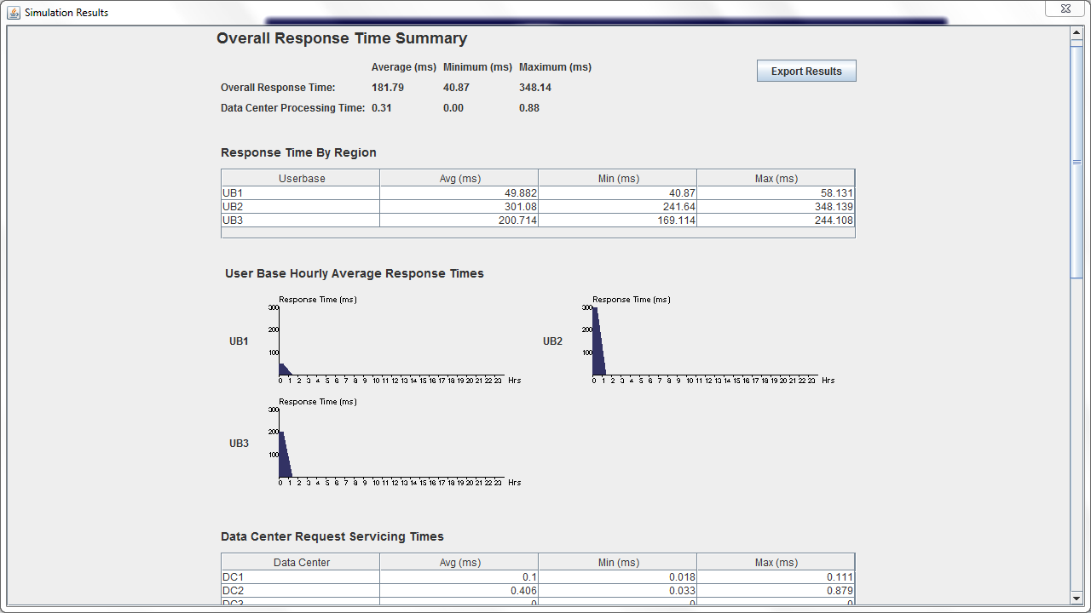

If you try to run the simulation again we get an error to restart the simulator and proceed .

**RESULT** : Thus ,we have successfully Simulated the Cloud environment using Cloud Analyst in CloudSim.